Team: SongScribe

Members: David Couto, DC Danko,

Tom Burrow, and Ben Chrobot

April 2, 2013

GPS and Wi-Fi Location Position Assessment

**The Goal:**

We set out to gain GPS and Wi-Fi/Service-Carrier-Triangulation data from one of the SongScribe team member’s phones. The team hoped this data would return useful data in the future prospect of location data. SongScribe gives the user the ability to tag MIDI melodies with emotions, pictures, and a time stamp, and the prospect of being able to record GPS location points for a recorded melody would be a useful feature for allowing a user to visualize locations on a Google Maps API of where he or she recorded past melodies. This builds onto the team’s vision to help producers track their progress and make it easier and faster to make professional and popular music.

**The Predictions:**

From the SongScribe team’s past experience with location, it is known that GPS is very inaccurate indoors (if it works at all). Newer phones will have the ability to utilize Google’s indoor location algorithms for detection on Wi-Fi and network triangulation for times when GPS is not an option, but the older the phone, the harder it is to pull useful data from these resources, pending on the age of the antennas used for cell coverage and Wi-Fi respectively (it was debated before testing whether Wi-Fi location would work at all on some older phones). The team’s goal is to test an Android phone’s GPS, Wi-Fi, and combined GPS-Wi-Fi tracking accuracy (specifically on an Motorola Droid 2 Global (3G) phone on Verizon in this circumstance).

**The Results:**

The findings of our GPS testing result from a test of Wi-Fi, GPS, and Wi-Fi-GPS location tracking from the Z-Center Athletic Facility to the end of the Infinite Corridor (Eastman Courtyard) on the MIT campus. The GPS test began in the Eastman Courtyard and ran to the Z-Center, the GPS and Wi-Fi test ran from the Z-Center to the Eastman Courtyard, and the Wi-Fi test ran from the Z-Center to Eastman Courtyard. Each test ran approximately five minutes.

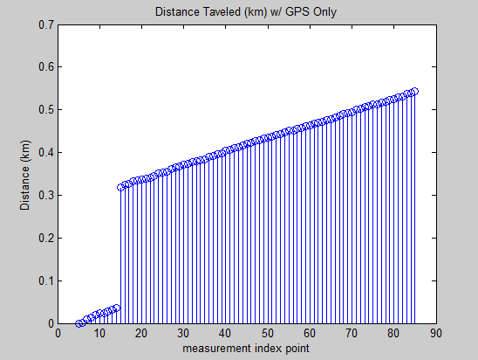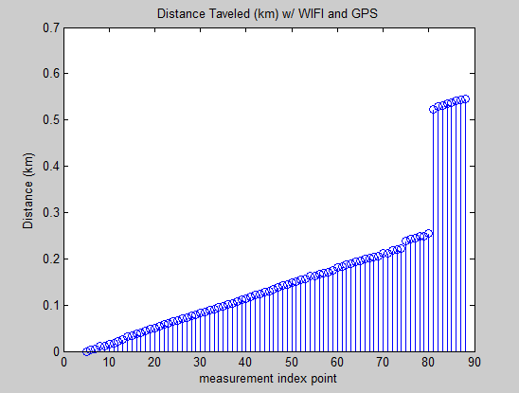

Figure 2

Figure 1

Unfortunately, as predicted, the Wi-Fi location tracking capabilities of this older-model Android phone was not able to report location accurately enough to retrieve latitude and longitude data from its test, and our app reported back an empty data set. The reported data sets for GPS and GPS and Wi-Fi appear to be very similar for this reason (the data in the GPS and Wi-Fi seems to be unaffected by the presence of Wi-Fi and based only on GPS data).

Figures 1 and 2 prove another of our predictions, the lack of GPS data indoors. By watching the live data from the app while recording, it was reported GPS was not found while in the Infinite Corridor, but it can also be seen in these figures where the distance traveled jump occurs (around 15 in Figure 1 and 80 in Figure 2). This jump shows the app’s recognition that a large amount of distance was covered in a very short period of time (the time when GPS was not functioning). This can also be seen in Figures 3 and 4, where the speed in more inconsistent around these times when the distance jumps occur. This consistency is important to note because it means GPS cannot be relied on in indoor circumstances. The Wi-Fi location lack of functionality tells the team older Android phones should not be relied on for indoor location. Further testing needs to be done on newer model phones to verify the use of indoor tracking in any model Android phone.

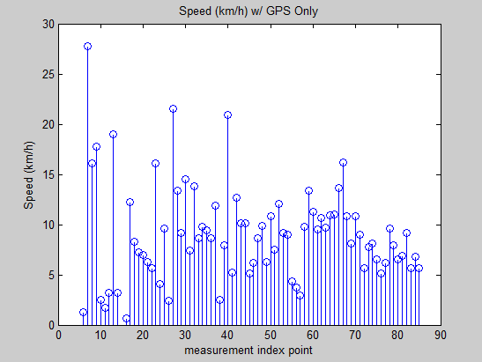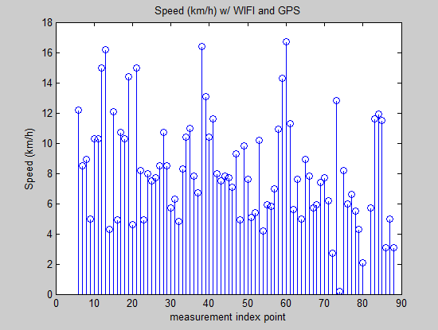

Figure 4

Figure 3

The final result was in the accuracy of the GPS. From Figures 5 and 6, it can be seen accuracy is within 5 to 10 feet, in this circumstance. This is because the walking paths can be seen on the Google maps API, which were the path of actual travel. The recorded path varies slightly in both circumstances (for most applications, this accuracy will be good). This error margin will be made note of for future implementation. The straight line path through the Infinite Corridor is further proof of the GPS failure indoors (the beginning and end locations of the Corridor were connected).

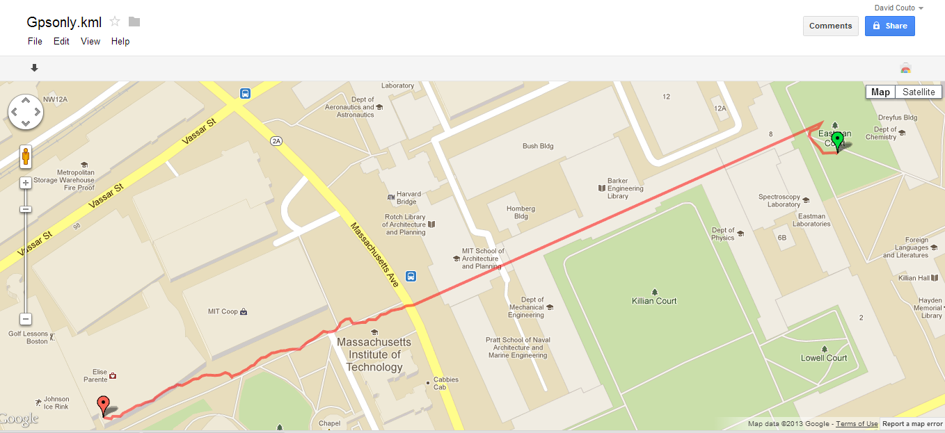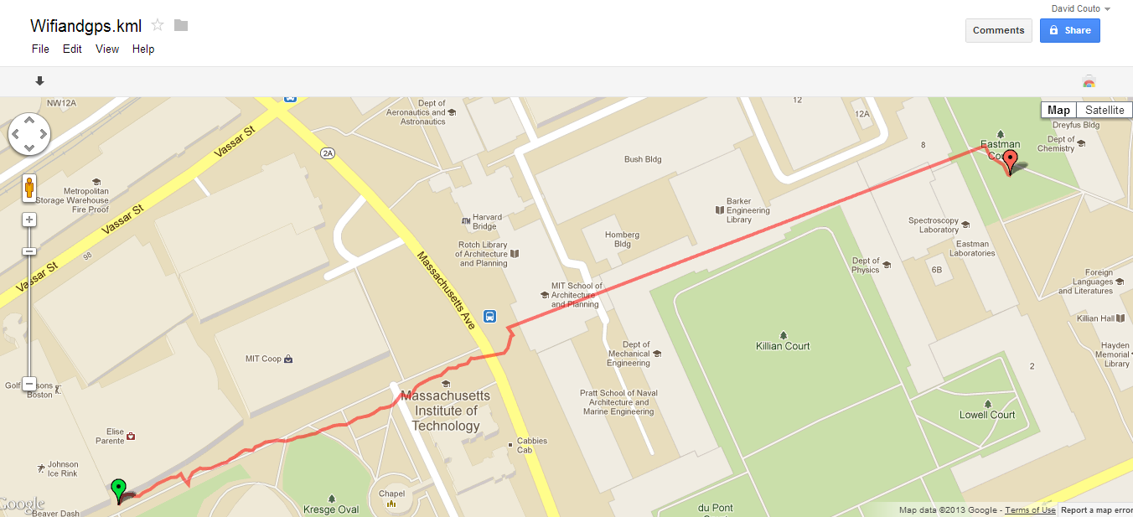

Figure 6

Figure 5